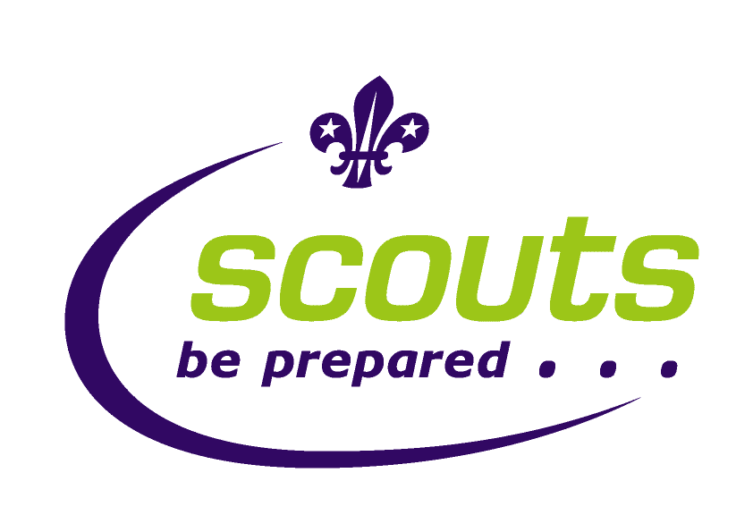
Bridges Walk Sponsor Form

Name ____________________________________
On Sunday 15th October Cubs/Scouts and Leaders will be walking the Thames path and crossing 8 London Bridges from Tower Bridge to Westminster Bridge, taking in iconic views and Landmarks of London on the way. The walk is approx. 4 miles.
Raising money to visit Gambia in 2018 as part of a community project, for more information visit www.ghisp.org.uk
If those who are sponsoring are UK taxpayers then if you complete the details below we will be able to claim gift aid on your contribution as well.
If I have ticked the box headed ‘Gift Aid’ √, I confirm that I am a UK Income or Capital Gains taxpayer. I have read this statement and want the charity or Community Amateur Sports Club (CASC) named above to reclaim tax on the donation detailed below, given on the date shown. I understand that I must pay an amount of Income Tax and/or Capital Gains Tax in the tax year at least equal to the amount of tax that all the charities and CASCs I donate to will reclaim on my gifts for that tax year. I understand that other taxes such as VAT and Council Tax do not qualify. I understand the charity will reclaim 25p of tax on every £1 that I have given.

Name | Address | Amount per Mile | Total Amount | Paid? | Gift Aid?
Remember – Full name +Home Address + Postcode + √ = giftaid it

